[Date]

Statement of
Environmental
Effects

Change of Use
Report: 2 x Unauthorised Existing Commercial Shops

Shops 75 – 77 Middleton Road,
Chester Hill.NSW.2162

Lots G and H, in DP36497

By AJ Design & Construction Pty Ltd
Email: john@ajdc.com.au
Mob: 0413 134 986

Figure 2- Site Context Plan (Six Maps, 2023) 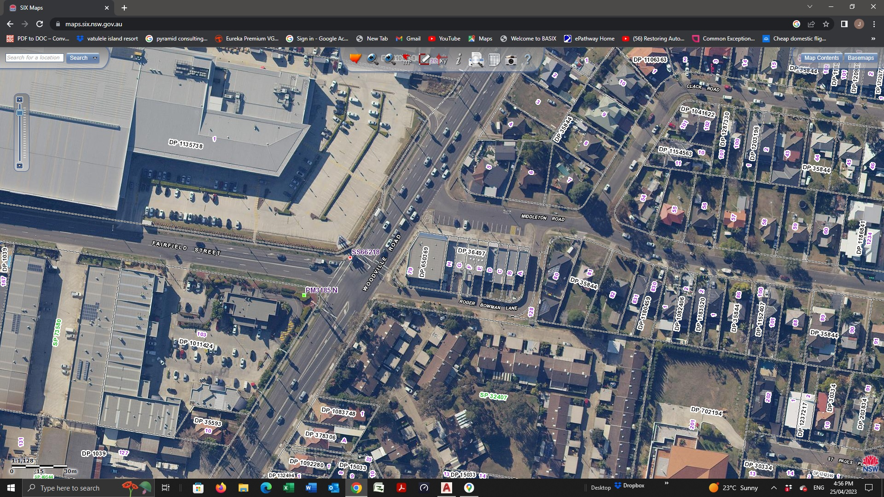

Site Analysis:
The shop is located at superior area, just off Woodville Road, where some Australia’s biggest retailers/main road users as Bing Lee, Officeworks, Supercheap Auto, Toyota New and used commercial yards are located, and many more commercial buildings are located, the building and its street frontage has a fantastic exposure and high traffic thoroughfare, the site is surrounded by a minimum of no less than 8 Government Catchment of schools.
The site is also surrounded by residential dwellings, the business is well zoned and situated within the region and is an enhancement to the governing areas.

INTRODUCTION

Bankstown Local Environmental Plan 2015 is Council's principal planning document to regulate effective and orderly development in the City of Bankstown. The LEP provides objectives, zones, and development standards such as lot sizes and floor space ratios.

Part B2 of Bankstown Development Control Plan 2015 supplements the LEP by providing additional objectives and development controls to enhance the function and appearance of centres, corridors, and business parks in the City of Bankstown. The development controls include storey limits, setbacks and building design.


Part B2 generally applies to land within the business zones in the City of Bankstown under the provisions of Bankstown Local Environmental Plan 2015.

Development controls

The development controls do achieve the objectives

1. Development does comply with the storey limit that corresponds with the maximum building height shown for the site on the Height of Building Map as follows:

Maximum building height as shown on the Height | Storey limit (not
of Buildings Map (Bankstown LEP 2015) | including basements)
11 metres for the following neighbourhood centres: | 3 storeys (no attic)
• 255A–257 Hector Street Bass Hill
• 259 Hector Street Bass Hill
• 360–366 Hector Street Bass Hill
• 826 Hume Highway Bass Hill
• 884–906 Hume Highway Bass Hill
• 207–231 Miller Road Bass Hill
• 35–55 Arlewis Street Chester Hill
• 172 Hector Street Chester Hill
• 178 Hector Street Chester Hill
• 63–79 Middleton Road Chester Hill
• 81–91 Miller Road Chester Hill
• 68–70B Miller Road Chester Hill
• 27 Woodville Road Chester Hill
• 35 Woodville Road Chester Hill
• 47 Woodville Road Chester Hill
• 101–109 Denman Road Georges Hall
• 21A–25A Hector Street Sefton
• 251 & 253 Hector Street Sefton
11 metres for all other neighbourhood centres | 2 storeys (plus attic)
14 metres | 4 storeys (no attic)

1.1 The minimum floor to ceiling height for a living area is 2.7 metres, we comply.

Setback to the primary and secondary frontages of allotments

1.2 The minimum setback to the primary and secondary frontages of an allotment is zero setback, the ground floor complies.

Setback to the side and rear boundaries of allotments

1.3 The development is adjacent to residential zoned land, the setbacks Council will remain the same minimum setbacks to the side and rear boundaries.

Food premises

1.4 The design, construction, and operation of a food premises do comply with:

- Food Act 2003;

- Food Regulation 2010;

- FSANZ Food Standards Code; and

- AS 4674:2004 Design, Construction, and Fit out of Food Premises.

Infrastructure

1.5 The siting of plant rooms, mechanical ventilation stacks, exhaust stacks and the like do,

- integrate with the architectural features of the building to which it is attached; or

- and are sufficiently screened when viewed from the street and neighbouring residential zoned land.

Conclusion :

My clients who bought the business, bought the business with the building ,fully noting that the restaurant was fully acceptable and met all the guidelines of the councils regulations and codes, they did not know that the restaurant was in any type of violation the councils codes and or approvals. My client Mr Nour Taleb, the proprietor of the business will fully assist and comply with any requirements needed to keep his business door to stay open.

The site is considered in a manner that will not dimmish the existing Residential fabric character of the locality The proposal is permitted within the zoning with councils consent and compliance and with the help of the Development Control Plan Part 2B Of the Commercial Centre Code.

Kind regards,

John Bousamra

